**Ecommerce Sales Dashboard Project**

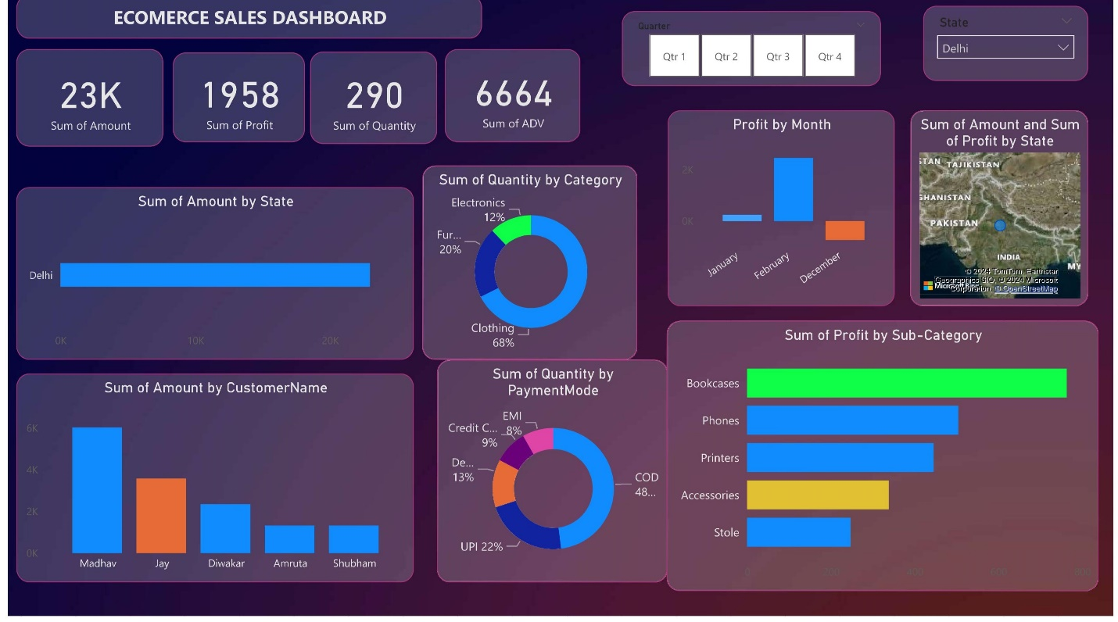

**Objective of the Project**

The objective of this project is to create an interactive **Ecommerce Sales Dashboard** using Power BI, which provides a comprehensive overview of sales performance across different states, categories, and customers. The dashboard aims to help stakeholders make informed decisions by offering insights into sales amount, profit, quantity, and payment modes.

**Key Insights from the Dashboard**

1. **Overall Sales Performance**
   * **Total Sales Amount:** The total sales amount is ₹23K.
   * **Total Profit:** The total profit generated is ₹1,958.
   * **Total Quantity Sold:** A total of 290 units have been sold.
   * **Total ADV (Average Daily Value):** The total ADV is 6,664.
2. **State-Wise Sales**
   * **Dominant State:** Delhi is the primary contributor to the sales, showing a significant sales amount compared to other states. This indicates a strong market presence in Delhi.
3. **Customer-Wise Sales**
   * **Top Customers:**
     + **Madhav** is the leading customer with sales amounting to over ₹6K.
     + **Jay** follows with a significant contribution, though less than Madhav.
     + **Diwakar, Amruta,** and **Shubham** have smaller but noticeable contributions.
   * This data could be used to personalize marketing efforts towards high-value customers.
4. **Category-Wise Sales**
   * **Clothing:** Contributes to 68% of the total quantity sold, making it the largest category.
   * **Furniture:** Accounts for 20% of the total quantity sold.
   * **Electronics:** Comprises 12% of the total quantity sold.
   * This insight suggests that clothing is the most popular product category.
5. **Profit by Sub-Category**
   * **Top Profitable Sub-Category:** Bookcases are the most profitable sub-category, with a significant profit margin compared to other sub-categories.
   * **Phones and Printers** also contribute positively, while **Accessories** and **Stole** have lower profit margins.
6. **Sales by Payment Mode**
   * **Cash on Delivery (COD):** The most preferred payment mode, accounting for 48% of the total quantity sold.
   * **UPI Payments:** UPI is the second most popular mode, contributing to 22%.
   * **Debit/Credit Cards and EMI:** Also used but to a lesser extent.
   * This insight can help in optimizing payment options and improving customer experience.
7. **Monthly Profit Trends**
   * **Highest Profit Month:** February shows the highest profit, followed by December.
   * **January:** Has a lower profit margin.
   * Understanding these trends can help in planning promotional activities and inventory management.

**Conclusion**

The dashboard provides valuable insights into the performance of the ecommerce business, highlighting areas of strength and potential improvement. Key customers, popular product categories, and preferred payment modes are clearly identified, offering opportunities for targeted marketing and strategic planning. The dashboard is a powerful tool for decision-makers to drive growth and enhance overall sales performance.

Top of Form

Bottom of Form